CHARTER TOWNSHIP OF GENESEE ORDINANCE NO. 573
AN ORDINANCE TO AMEND ORDINANCE NO. 475, THE GENESEE CHARTER TOWNSHIP ZONING ORDINANCE BY THE REZONING CERTAIN LAND FROM LIGHT INDUSTRIAL TO SINGLE-FAMILY RESIDENTIAL

The Charter Township of Genesee, Genesee County, Michigan Ordains:

SECTION I

REZONING OF PREMISES

Genesee Township Ordinance No. 475 is hereby amended to read as follows:

Pursuant to Article XVII Section 1707 entitled "Changes and Amendments" the zoning ordinance and zoning map is hereby amended pursuant to the recommendation of the Genesee Township Planning Commission, the following described premises in the Township of Genesee, Genesee County, Michigan are hereby rezoned from I-1, Light Industrial to R-1, Single-Family Residential.
Parcel No.: 11-06-200-036

A POL BEG N 26 DEG 01 MIN 44 SEC W 84.44 FT FROM SECOR OF NE 1/4 TH NWLY ALONG C/L OF DORT HWY 181.08 FT TH W 945.66 FT TH SELY 338.04 FT THE 472.3 FT THN 1 DEG 30 MIN 30 SEC W 75 FT THN 88 DEG 29 MIN 30 SEC E 315.79 FT TO POB & A PARCEL OF LAND BEG AT SW COR OF SE 1/4 OF NE 1/4 TH N 343.56 FT TH SE 477.54 FT TH W 343.20 FT TO POB SEC 6 T8N R7E (11) COMBINE ON 08/18/2010 FR 11-06-200-029, 11-06-200-002
MORE COMMONLY KNOWN AS: 8289 N Dort Highway

SECTION II

REPEAL

All ordinances and portions thereof insofar as the same may be in conflict herewith are hereby repealed.

SECTION III

EFFECTIVE DATE

This Ordinance shall become effective immediately upon publication following its final adoption.

SECTION IV

SHORT TITLE

This Ordinance shall be known as Genesee Township Zoning Ordinance Amendment No.

We hereby certify that the foregoing Ordinance was adopted on the Second Reading by the Township Board of the Charter Township of Genesee at its meeting on December 27, 2017

First Reading: Second Reading: Published on:

0
_D_e_c_em1 b_2_,e2_01r7_ December 27 2017
January 3, 2018

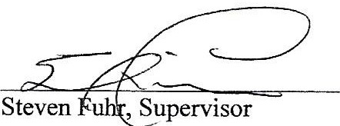

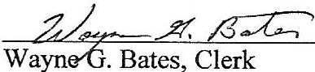

•

2

