CHARTER To,vNSHIP OF GENESEE

GENESEE COUNTY, MICHIGAN ORDINANCE NO. 576

An ordinance to adopt MCL 436.1703 which prohibits possession or consumption of alcohol by a minor, furnishing of fraudulent identification to a minor, use offraudulent identification by a minor, sets forth fines and sanctions for violation including repeated violation, requires notification of parent, custodian or guardian, requires alcohol screening and assessment, and sets forth alternative defenses and exceptions to MCL 436.1703.

THE CHARTER TO\VNSHIP OF GENESEE ORDAINS:

That MCL 436.1703 is hereby adopted as an Ordinance of the Charter Township of Genesee, Genesee County, Michigan.

Section 1: Severability

If any portion of this Ordinance shall be determined invalid or unconstitutional by a Court, the remainder shall be considered severable and shall remain in full force and effect.

Section 2: Publication

This Ordinance shall be published in a newspaper circulated within the Charter Township of Genesee, Genesee County, Michigan.

Section 3: Effective Date

This Ordinance shall take effect 30 days after its first publication.

Section 4: Certification

We hereby certify that the foregoing Ordinance No. 576 was adopted on the second reading
by the Township Board of the Charter Township of Genesee, Genesee County, Michigan.

First reading: February 13, 2018

First publication: February 21, 2018

Secondreading: March 13, 2018

Second public a tion : March 21, 2018
Charter Township of Genesee

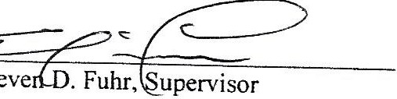
By:

By: µ/r & ,<f
ates,
Wayne G. C le rk

