CHARTER TOWNSHIP OF GENESEE ORDINANCE NO. 582
AN ORDINANCE TO AMEND ORDINANCE NO. 475, THE GENESEE CHARTER TOWNSHIP ZONING ORDINANCE BY THE REZONING CERTAIN LAND FROM HIGHWAY COMMERCIAL TO SINGLE FAMILY/ TWO-FAMILY RESIDENTIAL

The Charter Township of Genesee, Genesee County, Michigan Ordains:

SECTION I

REZONING OF PREMISES

Genesee Township Ordinance No. 475 is hereby amended to read as follows:

Pursuant to Article XVII Section 1707 entitled "Changes and Amendments" the zoning ordinance and zoning map is hereby amended pursuant to the recommendation of the Genesee Township Planning Commission, the following described premises in the Township of Genesee, Genesee County, Michigan are hereby rezoned from C-2, Highway Commercial, to R-2, Single­ Family/ Two-Family Residential:
0

Parcel No.: 11-34-576-035

N 280 FT OF LOTS 31 AND 32 CASHIN ACRES AND AP ARCEL OF LAND BEG IN THE CENTER OF RICHFIELD RD ONE LINE OF SAID LOT 31 EXTENDED TO E 194 FT THENS 660 FT THEN W 194 FT THEN N 660 FT TO PL OF BEG SEC 34 T8N R7E (93) OWNED AND OCCUPIED AS ON PARCEL FR 1100046997

MORE COMMONLY KNOWN AS: 4358 RICHFIELD RD., FLINT, MI 48506

SECTION II

REPEAL

All ordinances and portions thereof insofar as the same may be in conflict herewith are hereby repealed.

SECTION III

EFFECTIVE DATE

This Ordinance shall become effective immediately upon publication following its final adoption.

SECTION IV

SHORT TITLE

This Ordinance shall be known as Genesee Township Zoning Ordinance Amendment No.

We hereby certify that the foregoing Ordinance was adopted on the Second Reading by the Township Board of the Charter Township of Genesee at its meeting on February 1 2. zm 9
First Reading: January 15, 2019
Second Reading: February 12 , 2019 Published on: Fe..b r 1.u :t, ..-'--/ ;)-O d 019
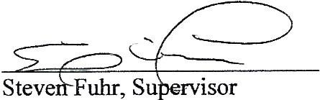
I

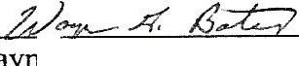

Wayn G.Bates, Clerk

•

2

