CHARTER TOWNSHIP OF GENESEE ORDINANCE NO. 586
AN ORDINANCE TO AMEND ORDINANCE NO. 475, THE GENESEE CHARTER TOWNSHIP ZONING ORDINANCE BY
THE REZONING CERTAIN LAND FROM AGRICULTURAL/RURAL TO HIGHWAY COMMERCIAL

The Charter Township of Genesee, Genesee County, Michigan Ordains:

SECTION I

REZONING OF PREMISES

Genesee Township Ordinance No. 475 is hereby amended to read as follows:

Pursuant to Article XVII Section 1707 entitled "Changes and Amendments" the zoning ordinance and zoning map is hereby amended pursuant to the recommendation of the Genesee Township Planning Commission, the following described premises in the Township of Genesee, Genesee County, Michigan are hereby rezoned from A-R (Agricultural/Rural Highway) to C-2 (Highway Commercial):
Q Parcel No.: 11-11-300-015
LOTS 1-6 BLK 2 VILLAGE OF GENESEE

MORE COMMONLY KNOWN AS: 7234 GLIDDEN STREET, GENESEE, MICHIGAN.

SECTION II

REPEAL

All ordinances and portions thereof insofar as the same may be in conflict herewith are hereby repealed.

SECTION III

EFFECTIVE DATE

This Ordinance shall become effective immediately upon publication following its final adoption.

SECTION IV

SHORT TITLE

This Ordinance shall be known as Genesee Township Zoning Ordinance Amendment No.
586.

We hereby certify that the foregoing Ordinance was adopted on the Second Reading by the Township Board of the Charter Township of Genesee at its meeting on April 17, 2019.

First Reading: Second Reading:
---=A=p r1=·1=--...,c9_

_ M_a_y_l_4
_,,2019

_,2019
First Publishe:d
April 17, 2019

Published on:
May 22, 2019

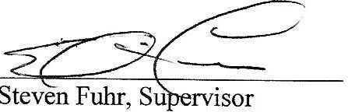

M .h". IJ,xq
Wayi; lirate,sClerk

•

2

