CHARTER TOWNSHIP OF GENESEE ORDINANCE NO. 587
AN ORDINANCE TO AMEND ORDINANCE NO. 475, THE GENESEE CHARTER TOWNSHIP ZONING ORDINANCE BY
THE REZONING CERTAIN LAND FROM HIGHWAY COMMERCIAL TO RESIDENTIAL

The Charter Township of Genesee, Genesee County, Michigan Ordains:

SECTION I

REZONING OF PREMISES

Genesee Township Ordinance No. 475 is hereby amended to read as follows:

Pursuant to Article XVII Section 1707 entitled "Changes and Amendments" the zoning ordinance and zoning map is hereby amended pursuant to the recommendation of the Genesee Township Planning Commission, the following described premises in the Township of Genesee, Genesee County, Michigan are hereby rezoned from R-2 (Residential) to C-2 (Highway Commercial):

Parcel No.: 11-06-200-020 and 11-06-200.- 021combined into new Parcel No. 11-06-200-037

ALL THAT PART OF NE¼ OF NE¼ LYING WLY OF DORT HWY EXCEPTS 1015 FT & THEE 153.90 FT OF NW¼ OF NE FR¼ EXCEPTS 330 FT AND W 146.4 FT OF E 300.3 FT OF NW¼ OF NE FR¼ EXCEPTS 450 FT SEC 6 T8N R7E (19)

MORE COMMONLY KNOWN AS: 8537 NORTH DORT HIGHWAY, MT. MORRIS TOWNSHIP, GENESEE COUNTY, MI 48458.

SECTION II

REPEAL

All ordinances and portions thereof insofar as the same may be in conflict herewith are hereby repealed.

SECTION ID

EFFECTIVE DATE

This Ordinance shall become effective immediately upon publication following its final adoption.

SECTION IV

SHORT TITLE

This Ordinance shall be known as Genesee Township Zoning Ordinance Amendment No.
587.

We hereby certify that the foregoing Ordinance was adopted on the Second Reading by the Township Board of the Charter Township of Genesee at its meeting on

First Reading:

M_ayl_4_ ,2019

Second Reading:

_ M_a_y_3_0
_,2019

Published on:
June 5, 2019

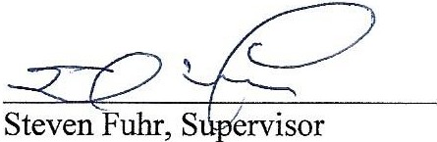

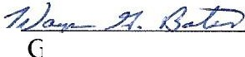

Wayn; ates, Clerk

•

2

