CHARTER TOWNSHIP OF GENESEE ORDINANCE NO. 588
AN ORDINANCE TO AMEND ORDINANCE NO. 475, THE GENESEE CHARTER TOWNSHIP ZONING ORDINANCE BY
THE REZONING CERTAIN LAND FROM HIGHWAY COMMERCIAL TO RESIDENTIAL

The Charter Township of Genesee, Genesee County, Michigan Ordains:

SECTION I

REZONING OF PREMISES

Genesee Township Ordinance No. 475 is hereby amended to read as follows:

Pursuant to Article XVII Section 1707 entitled "Changes and Amendments" the zoning ordinance and zoning map is hereby amended pursuant to the recommendation of the Genesee Township Planning Commission, the following described premises in the Township of Genesee, Genesee County, Michigan are hereby rezoned from C-2 (Highway Commercial) to C-1 (Neighborhood Commercial):

Parcel No.: 11-18-300-005

A PARCEL OF LAND BEG 134FT N OF SW CORNER OF SEC TH 112.5FT TH N 89 DEG 22MIN 13 SEC E 195 FT S 110.84FT TH S 88 DEG 52 MIN SEC W 195 FT TO PL OF BEG SEC 18 T8N R7E, 50 A (87) FROM 11-00-041-010.

MORE COMMONLY KNOWN AS: 6020 N. SAGINAW STREET, FLINT, GENESEE COUNTY, MI 48505.

SECTION II

REPEAL

All ordinances and portions thereof insofar as the same may be in conflict herewith are hereby repealed.

SECTION III

EFFECTIVE DATE

This Ordinance shall become effective immediately upon publication following its final adoption.

SECTION IV

SHORT TITLE

This Ordinance shall be known as Genesee Township Zoning Ordinance Amendment No.
588.

We hereby certify that the foregoing Ordinance was adopted on the Second Reading by the Township Board of the Charter Township of Genesee at its meeting on

First Reading: Second Reading:
M_ay_l_4_

_ M_ay_30

_,2019

_,2019

Published on:
June 5, 2019

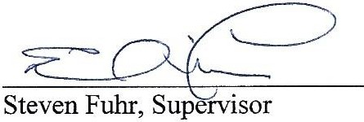

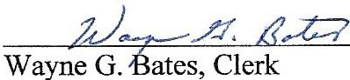

2

