CHARTER TOWNSHIP OF GENESEE ORDINANCE NO. 600
AN ORDINANCE TO AMEND ORDINANCE NO. 475, THE GENESEE CHARTER TOWNSHIP ZONING ORDINANCE BY THE REZONING CERTAIN LAND FROM FROM 1-1 (LIGHT INDUSTRIAL DISTRICT) TO R-1 (SINGLE FAMILY RESIDENTIAL)

The Charter Township of Genesee, Genesee County, Michigan Ordains:

SECTION I

REZONING OF PREMISES

Genesee Township Ordinance No. 475 is hereby amended to read as follows:

Pursuant to Artide XVII Section 1707 entitled "Changes and Amendments" the zoning ordinance and zoning map is hereby amended pursuant to the recommendation of the Genesee Township Planning Commission, the following described premises in the Township of Genesee, Genesee County, Michigan are hereby rezoned from I-1 (Light Industrial District) to R-1 (Single Family Residential):

Part of parcel 11-22-400-044 further known as 5147 N. Genesee Road, containing .29 of an acre. Request for rezoning is to straighten the boundary lines of the parcel and does not affect any road frontage. Full legal description is on file with the Genesee Township's Clerk's Office.

MORE COMMONLY KNOWN AS: VACANT LAND, GENESEE ROAD

SECTION II

REPEAL

All ordinances and portions thereof insofar as the same may be in conflict herewith are hereby repealed.

SECTION III

EFFECTIVE DATE

This Ordinance shall become effective immediately upon publication following its final adoption.

SECTION IV

SHORT TITLE

This Ordinance shall be known as Genesee Township Zoning Ordinance Amendment No.
2020-600.

We hereby certify that the foregoing Ordinance was adopted on the Second Reading by the Township Board of the Charter Township of Genesee at its meeting on April 14. 2020.

First Reading: Second Reading: Published on:
_M_a_r_c_h_l?_ ,2020

_A_p_r_i_l_l4_ _, 2020
April 22, 2020
Published: March 25, 2020

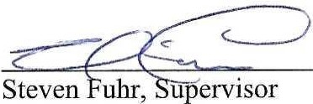

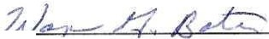
Wayne Bates, Clerk

2

