CHARTER TOWNSHIP OF GENESEE GENESEE COU NTY, MICHIGAN

ORDINANCE NO. 2021- 611

AN ORDINANCE AMENDING THE GENESEE TOWNSHIP ZONING ORDINANCE 603 BY THE ADDITION AND REMOVAL OF CERTAIN LANGUAGE REGULATING DOMESTIC ANIM ALS IN CERTAIN SIZED PARCELS WITHIN THE TOWNSHIPAND TO PROVIDE FOR THE PENALTY FOR THE VIOLATION THEREOF

THE CHARTER TOWNSHIP OF GENESEE ORDAINS:

SECTION I

The Cha rt er Tow nship of Genesee Zoning Ordina nce Section 1416 shall read as follows:

Section 1416 Livestock and Domestic Animals

(1) The keeping of cows, she ep, pigs, hogs, goats, horses or ot her such livestock is prohibited on any parcel of land less than five (5) acres in size, provided the number of suc h animals shall not exceed one {1) animal per first five (5) acres, and one (1) an i ma l per t wo and a half (2.5) acres thereafter. Domestic anima ls, such as cats, dogs, and rabbit s, may be kept on any parcel of land not exceeding four (4) animals.

The remainder of the section remains unchanged.

SECTION Ill

The provisions of this ordinance are hereby declared to be severable. If any clause, sent ence, word, sect ion, or provision is hereaft er declared void or unenforceable for any reason by a court of competent jurisdict ion, it shal l not affect the remainder of such or dinan ce which shall cont i nu e in fullforce an d eff ect .

SECTION IV

All or din ances or parts of ordinances in conflict herewith are hereby repealed.

SECTION V

This Ordinance shall be published in a newspaper of general circulat ion within the Charter Township of Gene see, Genesee County, Michigan, and shall become effective 7 days aft er publication.
SECTION VI
A copy of this Ordinance may be inspected at the Township Clerk's Office at the Genesee Township Hall, 7244 N. Genesee Rd., Genesee, Ml 48437 during regular
busin ess hours.

*****************************************************************************
We hereby certify that the foregoing Ordinance was adopted on the Second Reading by the Township Board of Trustees on July 13 , 2021.

First Reading: June 8, 2021
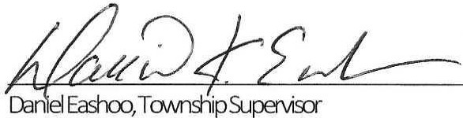
Second Re ading: July 13 , 202 1
Publi cation : July 21, 2021
Pub l i s he d : June 16 , 2021

