CHARTER TOWNSHIP OF GENESEE ORDINANCE NO. 618
AN ORDINANCE TO AMEND ORDINANCE NO. 603, THE GENESEE CHARTER TOWNSHIP ZONING ORDINANCE BY THE REZONING OF CERTAIN LAND FROM C-2 (HIGHWAY COMMERCIAL) TO R-1 (SINGLE FAMILY RESIDENTIAL)

The Charter Township of Genesee, Genesee County, Michigan Ordains:

SECTION I

REZONING OF PREMISES

Genesee Township Ordinance No. 603 is hereby amended to read as follows:

Pursuant to Article XVII Section 1706 entitled "Changes and Amendments" the zoning ordinance and zoning map is hereby amended pursuant to the recommendation of the Genesee Township Planning Commission, the following described premises in the Township of Genesee, Genesee County, Michigan are hereby rezoned from C-2, Highway Commercial to R-1, Single­ Family Residential:

Parcel No.: 11-07-551-009 LOT 22 ORCHARD HILLS
MORE COMMONLY KNOWN AS: G-7126 N. Saginaw Street, Mt. Morris, Michigan 48458

SECTIONil

REPEAL

All ordinances and portions thereof insofar as the same may be in conflict herewith are hereby repealed.

SECTION III

EFFECTIVE DATE

This Ordinance shall become effective immediately upon publication following its final adoption.

SECTION IV

SHORT TITLE

This Ordinance shall be known as Genesee Township Zoning Ordinance Amendment No.

2021-618.

We hereby certify that the foregoing Ordinance was adopted on the Second Reading by the Township Board of the Charter Township of Genesee at its meeting on 1 2 - 2 3- 2 O 21

First Reading: Second Reading:

De cembe r 1 2021 December 23 , 2021

Published on:
1st Pu b . 1 2 - 2 2 - 2 0 2 1
2nd Pu b . 1 2 - 29 - 2 0 2 1

u "'Q ol
s
Daniel Eashoo, Supervisor

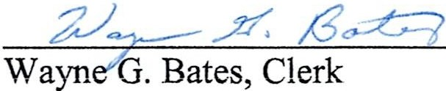

2

