CHARTER TOWNSHIP OF GENESEE GENESEE COUNTY, MICIDGAN ORDINANCE NO. 626

An Ordinance to amend Section 9.3 of Article IX of Genesee Township Ordinance No. 379 which prohibits the possession of any controlled substance by any person in the Township and provides penalties for violation thereof.

THE CHARTER TOWNSHIP OF GENESEE, MICIDGAN ORDAINS:

That Section 9.3 of Article IX of Genesee Township Ordinance No. 379 is hereby amended to read as follows:

Section 9.3
- It shall be unlawful for any person to possess any controlled substance as defined in Act No. 368 of the Public Acts of Michigan of 1978 (MCL 333.7101 et seq., MSA 14.15(7101) et seq.), as amended, except as authorized by the Michigan Public Health Code.

Penalty
- A person convicted of violating this Ordinance shall be punished by a fine of not more than $500.00 or by imprisonment for not more than 90 days or by both such fme and imprisonment.

Severability
If any portion of this Ordinance shall be determined invalid or unconstitutional by
a Court, the remainder shall be considered severable and shall remain in full force and effect.

Publication
This Ordinance shall be published in a newspaper circulated ·Nithin the Charter
Township of Genesee, Genesee County, Michigan.

Effective Date
This Ordinance becomes effective upon publication after its adoption. A summary of this Ordinance must be published in a newspaper circulated within the Charter Township of Genesee, Genesee County, Michigan.

Certification
We, the undersigned, being respectively the Township Supervisor and Township
Clerk of the Charter Township of Genesee, Genesee County, Michigan, do hereby certify that the above Ordinance was duly adopted by the Township Board of the Charter Township of Genesee at which meeting a quorum was present.

Introduction: April 11, 2023
Second Reading: May 9, 2023

Firstpublication: April 19, 2023

Adoption: May 1 7 , 2 0 23

Second publication: May 17 , 2023
Charter Township of Genesee, Genesee County, Michigan

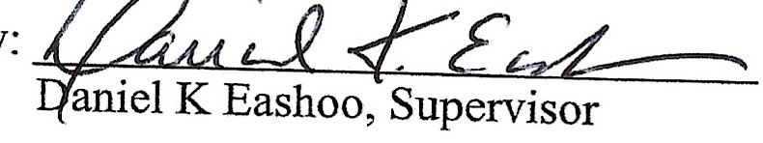

By: - ./f: &-:a
WaynG. Bates, Clerk

